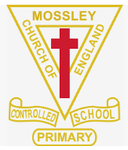
Mossley Primary School

Top tips to help your child become a brilliant historian

• Talk to your child about your family history. Trace your family’s historical roots

•Look at and analyse pictures from the past

•Travel to historical places

•Watch historical films and documentaries together

•Teach your child about key historical figures

•Encourage learning life lessons from history

•Cooking historical recipes and understanding why people of this time had a particular diet

•Learn more about history through art

•Learn more about history through music

•Embrace Horrible Histories

•Look at history of the local area

People without the knowledge of their past history, origin and culture is like a tree without roots

– Marcus Garvey

